**Day 1 Lab Assignments**

1. Try to make html page using HTML5 structural elements, similar to this layout:

And test your page using <https://validator.w3.org/>

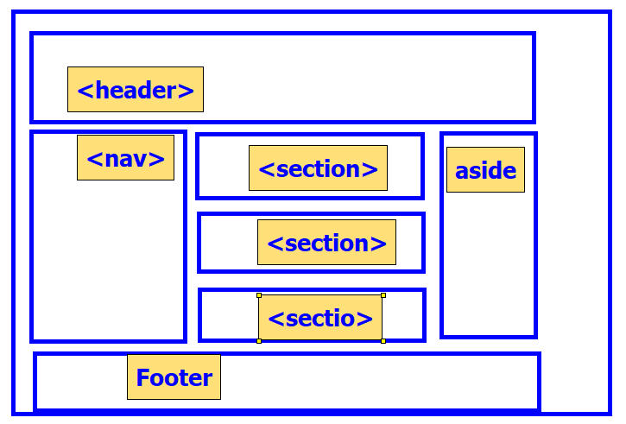

1. Make simple CV with skill bars indicating your skills (use meter), as the following:

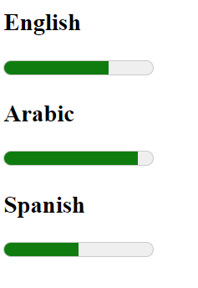

* 1. making it as circles is **Bonus**.

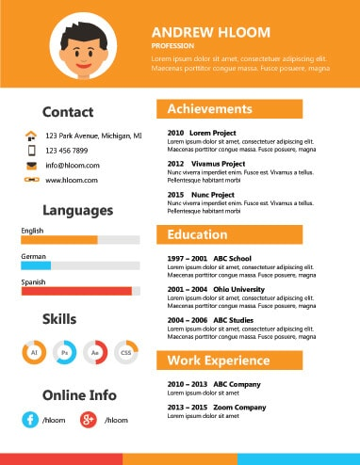

1. In assignment No.2 ,Use Time tag to display your birthrate in this page.
2. In assignment No.2, Use hidden audio element (without controls),and make button to play and another to pause.
3. In Assignment No.2, use video element to display a video about you in your page.
4. Test new input tags attribute(datalist – image – file - details… etc)
5. Use HTML5 drag and drop, to make the following assignment:

Make a div with width and height: 500px, and make a border and background color for it, and make an image that can be dragged and dropped on the div.

* 1. Make 3 images,
  2. **make the div allowing drop of specific image only (bonus)**

**<Thank>YOU </Thank>**